Project Planning Phase Sprint Delivery Plan

|  |  |
| --- | --- |
| Date | 29 October 2022 |
| Team ID | PNT2022TMID23095 |
| Project Name | IOT BASED SMART CROP PROTECTION SYSTEM FOR AGRICULTURE |
| Maximum Marks | 8 Marks |

Sprint Schedule:

|  |  |  |  |  |  |
| --- | --- | --- | --- | --- | --- |
| **Sprint** | **Functional**  **Requirement (Epic)** | **User Story / Task** | **Story Points** | **Priority** | **Team Members** |
| Sprint-1 | Registration | As a team leader, I can enrolled for the project by giving my email , password and within that I enter my team members name and their email . | 2 | High | Aathitheya A |
| Sprint-1 |  | As a Team Leader, I will receive confirmation email once , I have enrolled for the project with team id and along with  team members name. | 2 | High | Aathitheya A |
| Sprint-2 | Login | As a team member, I can login to the IBM portal by entering email & password . | 1 | Medium | Chalene T |
| Sprint-2 |  | As a team member, I can login to the IBM portal by entering email & password . | 1 | Medium | Narmadha AD |

|  |  |  |  |  |  |
| --- | --- | --- | --- | --- | --- |
| **Sprint** | **Functional Requirement**  **(Epic)** | **User Story / Task** | **Story Points** | **Priority** | **Team Members** |
| Sprint-2 |  | As a team member, I can login to the IBM portal by entering email & password . | 1 | Medium | Elayavarman R M |

Project Tracker, Velocity & Burndown Chart:

|  |  |  |  |  |  |  |
| --- | --- | --- | --- | --- | --- | --- |
| **Sprint** | **Total Story Points** | **Duration** | **Sprint Start Date** | **Sprint End Date (Planned)** | **Story Points Completed (as on**  **Planned End Date)** | **Sprint Release Date (Actual)** |
| Sprint-1 | 20 | 6 Days | 22 Oct 2022 | 27 Oct 2022 | 20 | 29 Oct 2022 |
| Sprint-2 | 20 | 6 Days | 31 Oct 2022 | 05 Nov 2022 | 30 | 30 Oct 2022 |
| Sprint-3 | 20 | 6 Days | 07 Nov 2022 | 12 Nov 2022 | 49 | 6 Nov 2022 |
| Sprint-4 | 20 | 6 Days | 14 Nov 2022 | 19 Nov 2022 | 50 | 7 Nov 2022 |

**Velocity:**

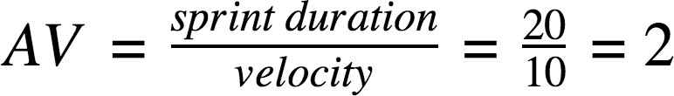

**Burndown Chart:**

